**Football Standings Application**

* Steps to access backend java application:

1. Clone below git repository and get the code into your Eclipse (or) Spring Tool Suite (STS) IDE.

Git Repository URL: <https://github.com/SivaPrasadNukella/FootballStandingsApp>

1. To run the test cases, right click on the application and **Run as** **Maven test**.
2. Right click on the application and **Run as Spring Boot App**.
3. The application will be up and running on port no **8081**. To test it just enter the below URL in browser and see the response.

<http://localhost:8081/api/standings>

* Steps to access frontend react js application:

1. Clone below git repository and get the code into your local system drive.

Git Repository URL:

<https://github.com/SivaPrasadNukella/FootballStandingsUI>

1. Open windows command prompt as Administrator and go to react js project folder as shown below.



1. Install **npm**, **axios** and **bootstrap** modules by executing below commands one by one in command promt.

* **npm install**
* **npm install axios**
* **npm install bootstrap --save**







1. Now you are ready to run the react js application. Just execute the below command to start the react js application.

* **npm start**

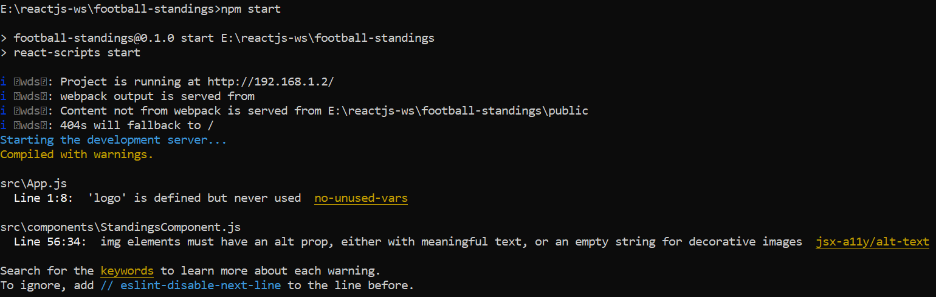

1. It will automatically launches browser and hits the below URL. It makes use default port number as 3000.

<http://localhost:3000/>

1. In case it didn’t launch browser, just open browser and hit the above URL manually.

* Below are the application screen shots.

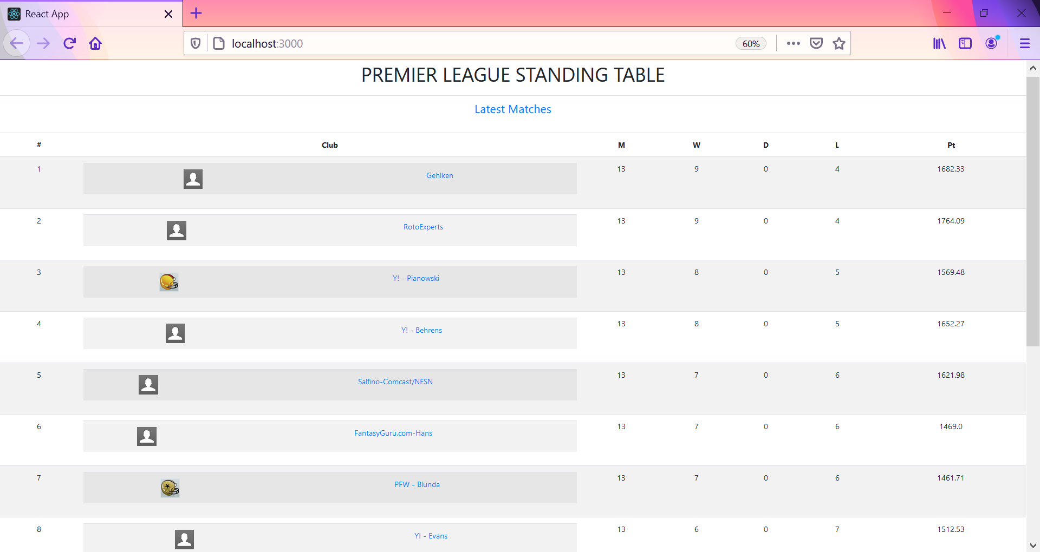

* To get team details, please click upon **Icon** (or) **Team Name** present under **Club** column.

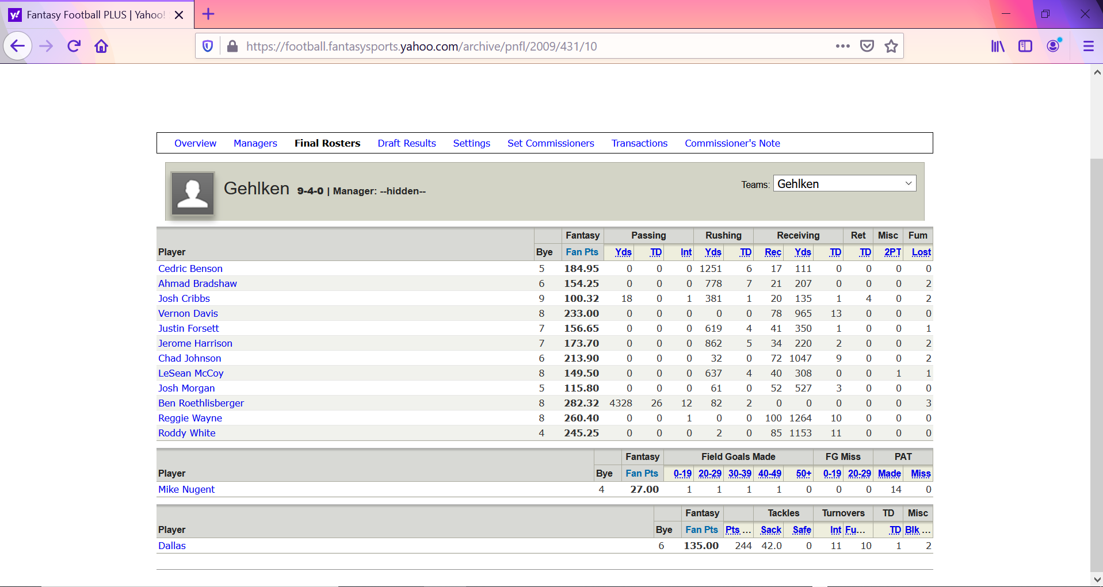

* To know specific player details, please click upon player link present under **Player** column.

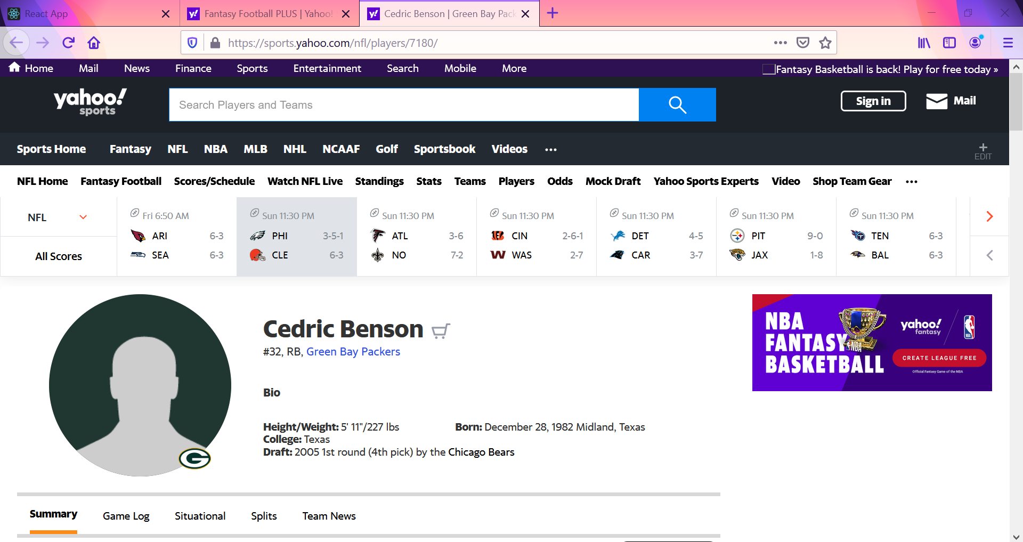

* To get Latest Matches details, please click upon **Latest Matches** link in second row.

